# ANALYSIS AND DESIGN OF ASIA.PLAYSTATION.COM

This report was made to complete a big project of

Programming Web Courses



Created by:

1. Muhammad Naimullah 1301160449
2. Muhammad Farhan W. 1301174587
3. Syiti Liviani M. 1301174515
4. Wong Shu Kheng 1301183631

**BACHELOR OF INFORMATICS**

**SCHOOL OF COMPUTING**

**TELKOM UNIVERSITY**

**BANDUNG**

**2019**

# TABLE OF CONTENTS

*Made automatically. See the tutorial at:*<https://www.youtube.com/watch?v=QbX0zYkIQyo>

# LIST OF FIGURES

*Made automatically. See the tutorial at:* <https://www.youtube.com/watch?v=Lnd_7uELeiM>

# LIST OF TABLES

*Made automatically. See the tutorial at:* <https://www.youtube.com/watch?v=Lnd_7uELeiM>

# CHAPTER I Introduction

## About Web

Asia.playstation.com is an official website from playstation that shows the products, games, and news from playstation. It also has playstation network for playstation user that consists of playstation store, playstation plus, playstation music, and playstation app. We can buy the games through the playstation store website, but we have to make a sony account first. The reason why we choose this website is because it has interesting interface and we love playstation games.

## Limitation of Work

Pages that we are going to build are:

1. Homepage (<https://asia.playstation.com/en-id/>)
2. Product page (<https://asia.playstation.com/en-id/ps4/>)
3. Games page (<https://asia.playstation.com/en-id/ps4/games/>)
4. PlayStation Network page (<https://asia.playstation.com/en-id/psn/>)
5. News page (<https://asia.playstation.com/en-id/press-releases/>)
6. Support page (<https://asia.playstation.com/en-id/support/>)
7. Create account page (<https://id.sonyentertainmentnetwork.com/create_account/?service_entity=urn%3Aservice-entity%3Apsn&hidePageElements=SENLogo&disableLinks=SENLink&ui=pr&response_type=code&request_locale=en_ID&state=returning&redirect_uri=https%3A%2F%2Fstore.playstation.com%2Fen-id%2Fhome%2Fgames%3Fsmcid%3Did-en_ps%3Acom_header&client_id=f6c7057b-f688-4744-91c0-8179592371d2&scope=kamaji%3Acommerce_native%2Ckamaji%3Acommerce_container%2Ckamaji%3Alists#/create_account/wizard/account_info_page1?entry=%2Fcreate_account>)
8. Sign in page (<https://id.sonyentertainmentnetwork.com/signin/?response_type=code&redirect_uri=https%3A%2F%2Fstore.playstation.com%2Fen-id%2Fhome%2Fgames%3Fsmcid%3Did-en_ps%253Acom_header&client_id=f6c7057b-f688-4744-91c0-8179592371d2&scope=kamaji%3Acommerce_native%2Ckamaji%3Acommerce_container%2Ckamaji%3Alists&prompt=login&state=returning&request_locale=en_ID&service_entity=urn%3Aservice-entity%3Apsn&hidePageElements=SENLogo&disableLinks=SENLink&ui=pr&error=login_required&error_code=4165&error_description=User+is+not+authenticated&no_captcha=false#/signin?entry=%2Fsignin>)
9. Account settings page (<https://id.sonyentertainmentnetwork.com/id/management/#/p?pr_referer=cam&state=a9ca01be88686704ace231a5c3ba5570&cid=5c0de5aa-053e-4917-8454-e25144746adf&entry=%2Fp>)
10. Admin dashboard page
11. View games page
12. Edit games page

Pages that will be used as a CRUD system are:

1. Create account page (CREATE)
2. Sign in page (READ)
3. Account settings page (UPDATE and DELETE)
4. Admin dashboard page (CRUD)

## Job Description

|  |  |  |  |
| --- | --- | --- | --- |
| No | Name | Student ID | Job Description |
| 1. | Muhammad Naimullah | 1301160449 | REPORT: Create usecase diagram  VIEW: front_page.php, user_profile.php  MODEL: UserModel.php  CONTROLLER: front.php, account.php |
| 2. | Muhammad Farhan W. | 1301174587 | REPORT: Create usecase scenario  VIEW: admin_front_page.php, admin_games.php, admin_product.php, admin_psn.php, admin_support.php, admin_view_games.php, in_front_page.php, in_games.php, in_product.php, in_psn.php, in_support.php, in_view_games.php, product.php, support.php  CONTROLLER: front.php |
| 3. | Syiti Liviani M. | 1301174515 | REPORT: Create ERD  DATABASE: asiaplaystation.sql  VIEW: create_account.php, create_account2.php, create_account3.php, dashboard_admin.php, games.php, view_games.php, login.php, edit_games.php  MODEL: UserModel.php, GamesModel.php  CONTROLLER: account.php, front.php, games.php |
| 4. | Wong Shu Kheng | 1301183631 | REPORT: Create business process  VIEW: psn.php |

# CHAPTER II Analysis and Design

## 2.1. Business process

In asia.playstation.com, there are 2 users which are customer and admin. Each customer has a username, name, password, avatar, phone number, email, gender, an address. Customers can see all updated info about playstation. Customer can see the products, games, and news from playstation. Each game has game ID, name, picture, genre, price, size, provider, release date, and description, while each news has news ID, title, date, type, and content. Customer can also see PSN features such as playstation store page, playstation music, playstation app, and playstation plus. If customers had any trouble, they can go to support and see FAQ about playstation’s product. Customer can buy many games, but they need to make an account first. Customers will choose which game they want to buy and add it to their cart. After they finished, they will proceed to payment page. Besides customers, there is also admin that has email, password, and admin ID. Admin will manage the website, so he can add, update, or delete games and news.

## 2.2. Designing Entity Relationship Diagrams

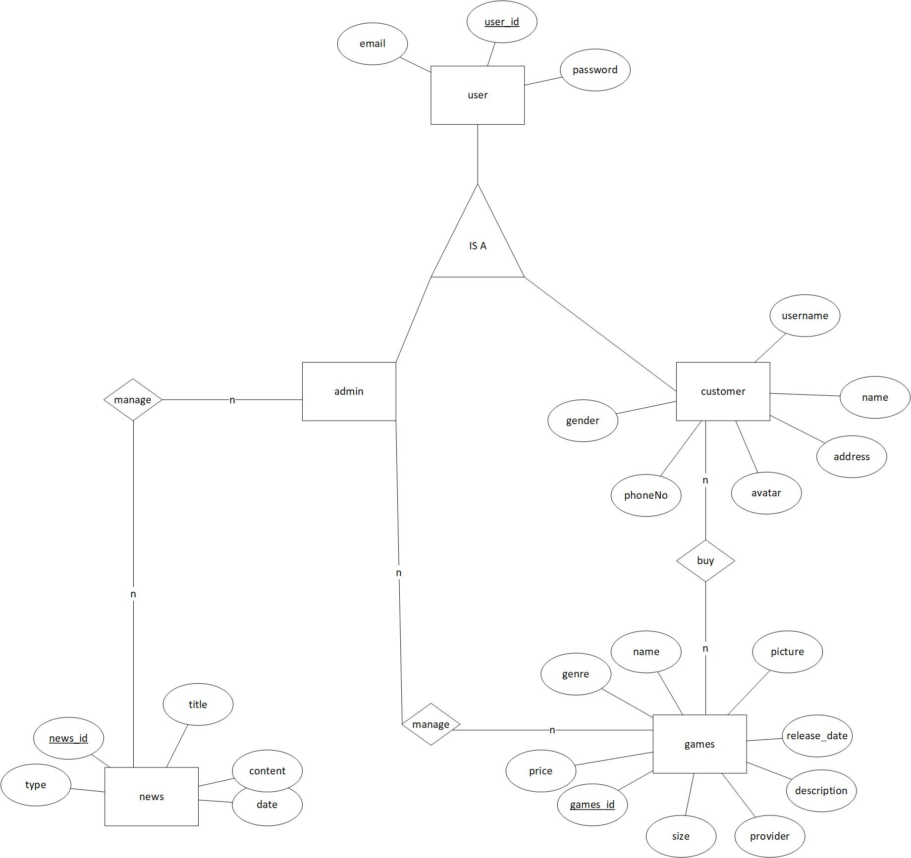

## 2.3. *Use case Diagram* and *Use case Scenario*

### 2.3.1. *Use case Diagram*

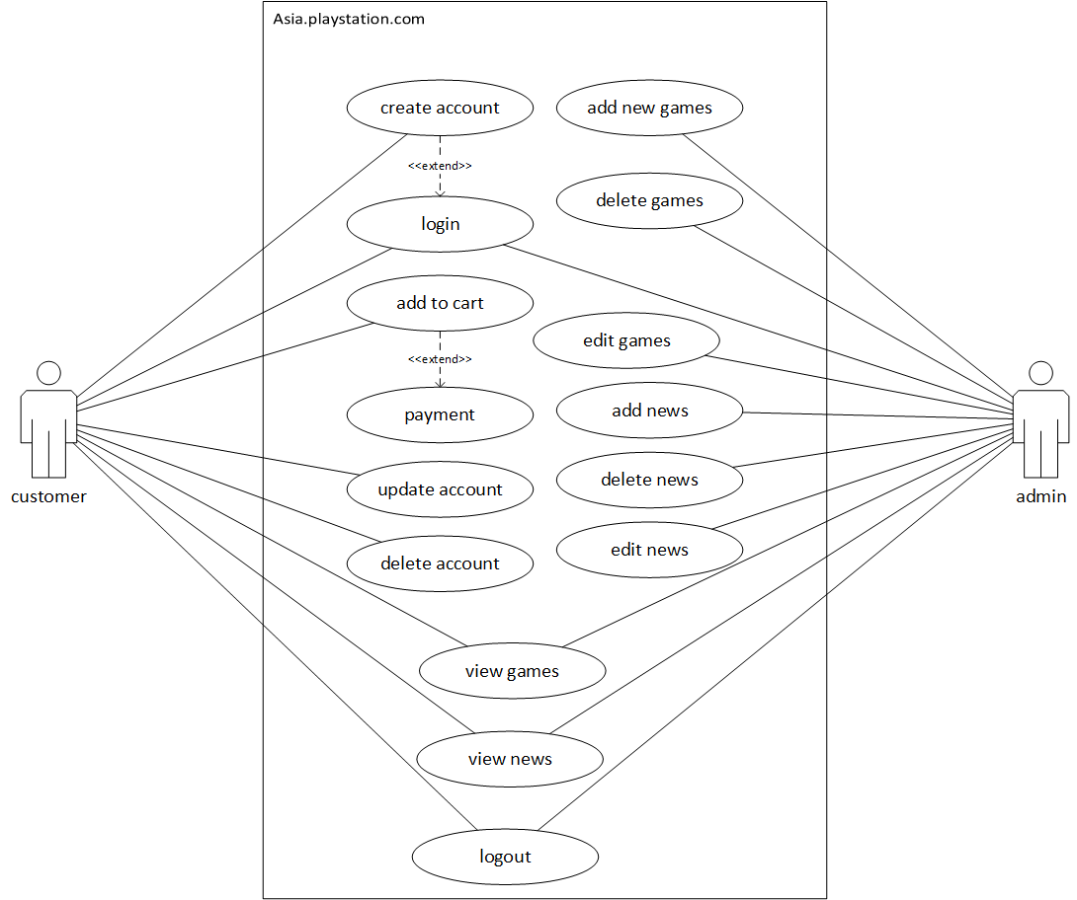

*Insert an image of use case diagram*

### 2.3.2. *Use case Scenario*

*Scenarios are made for each use case (based on point 2.3.1), the scenario template is as follows.*

Use case Name: Create Account

Actor : Customer

Pre-Condition : Open Sign in page

Post-Condition : Account is saved on database user

Description : Actor has to create an account for this website to be able to login

|  |  |
| --- | --- |
| Actor | System |
| 1. Click on “Create New Account” |  |
|  | 1. Display create account page |
| 1. Click on “Start” |  |
|  | 1. Display create account form |
| 1. Input email and password |  |
|  | 1. If email is not valid, back to (5). If valid, save data and show next create account form |
| 1. Input address, phone number, username and full name |  |
|  | 1. Save data and show finish form |
| 1. Click “Create Account” |  |
|  | 1. Store data in database user and show login page |

Use case Name: Login

Actor : Customer, Admin

Pre-Condition : Actor has an account

Post-Condition : Actor has successfully logged in

Description : Actor has to login to access more features

|  |  |
| --- | --- |
| Actor | System |
| 1. Click on “Sign in” |  |
|  | 1. Display sign in page |
| 1. Input email and password |  |
|  | 1. System match the data entered by the actor with database. If the data doesn’t match, the system will send the notifications “login denied” and actor should return to step 3, if matched, then system display homepage after login |

Use case Name: Add to cart

Actor : Customer

Pre-Condition : Actor has logged in and open games page

Post-Condition : Game successfully added to cart

Description : Actor adds the chosen game into their cart

|  |  |
| --- | --- |
| Actor | System |
| 1. Actor click on “add to cart” symbol on the chosen game |  |
|  | 1. System added the chosen game into table Cart in database |

Use case Name: Payment

Actor : Customer

Pre-Condition : Actor has finished added games to cart and open cart page

Post-Condition : Actor has to pay through outside payment

Description : Actor pays for the games

|  |  |
| --- | --- |
| Actor | System |
| 1. Actor click “proceed to payment” |  |
|  | 1. System display payment page |
| 1. Actor fills information needed for games shipment |  |
|  | 1. System display payment method |
| 1. Actor choose payment method |  |
|  | 1. System shows receipt and cart is empty again |

Use case Name: Update account

Actor : Customer

Pre-Condition : Actor open manage account page

Post-Condition : Actor has successfully updated their profile

Description : Actor edits their profile

|  |  |
| --- | --- |
| Actor | System |
| 1. Actor clicks edit on name/gender/address |  |
|  | 1. System display the chosen form |
| 1. Actor changes the data in the form |  |
| 1. Actor clicks save |  |
|  | 1. Changes is saved in database |
| 1. Actor clicks security |  |
|  | 1. System display security page |
| 1. Actor clicks edit on email/password/mobile phones |  |
|  | 1. System display the chosen form |
| 1. Actor clicks save |  |
|  | 1. Changes is saved in database |

Use case Name: Delete Account

Actor : Customer

Pre-Condition : Actor open manage account page

Post-Condition : Actor has successfully deleted their profile

Description : Actor deletes their account

|  |  |
| --- | --- |
| Actor | System |
| 1. Actor clicks security |  |
|  | 1. System display security page |
| 1. Actor clicks delete account |  |
|  | 1. System delete user’s account from database |
|  | 1. System show homepage before login |

Use case Name: View Games

Actor : Customer, Admin

Pre-Condition : Actor open games page

Post-Condition : Actor has viewed the game

Description : Actor views game

|  |  |
| --- | --- |
| Actor | System |
| 1. Actor clicks on one of the games |  |
|  | 1. System display game’s info in new page |

Use case Name: View News

Actor : Customer, Admin

Pre-Condition : Actor open news page

Post-Condition : Actor has viewed the news

Description : Actor views news

|  |  |
| --- | --- |
| Actor | System |
| 1. Actor clicks on one of the news |  |
|  | 1. System display news in new page |

Use case Name: Add new games

Actor : Admin

Pre-Condition : Actor open dashboard

Post-Condition : Actor has added new games into database

Description : Actor is adding new games into database

|  |  |
| --- | --- |
| Actor | System |
| 1. Actor clicks on add new game |  |
|  | 1. System display add new game page |
| 1. Actor fill in the form |  |
| 1. Actor click finish |  |
|  | 1. Store the data into table Games in database and show it on games page |

Use case Name: Delete news

Actor : Admin

Pre-Condition : Actor open dashboard

Post-Condition : Actor has deleted game from database

Description : Actor deletes game from database

|  |  |
| --- | --- |
| Actor | System |
| 1. Actor clicks on show game list |  |
|  | 1. System display game list |
| 1. Actor click delete on one of the games |  |
|  | 1. System delete the chosen games from database |

Use case Name: Edit games

Actor : Admin

Pre-Condition : Actor open dashboard

Post-Condition : Actor has updated game info in database

Description : Actor edits the game’s info

|  |  |
| --- | --- |
| Actor | System |
| 1. Actor clicks on show game list |  |
|  | 1. System display game list |
| 1. Actor click edit on one of the games |  |
|  | 1. System display the game info form |
| 1. Actor changes the game info |  |
| 1. Actor click save |  |
|  | 1. System save the data into database |

Use case Name: Add news

Actor : Admin

Pre-Condition : Actor open dashboard

Post-Condition : Actor has added news into database

Description : Actor is adding news into database

|  |  |
| --- | --- |
| Actor | System |
| 1. Actor clicks on add news |  |
|  | 1. System display add news page |
| 1. Actor fill in the form |  |
| 1. Actor click finish |  |
|  | 1. Store the data into table News in database and show it on news page |

Use case Name: Delete games

Actor : Admin

Pre-Condition : Actor open dashboard

Post-Condition : Actor has deleted news from database

Description : Actor deletes news from database

|  |  |
| --- | --- |
| Actor | System |
| 1. Actor clicks on show news list |  |
|  | 1. System display news list |
| 1. Actor click delete on one of the news |  |
|  | 1. System delete the chosen news from database |

Use case Name: Edit news

Actor : Admin

Pre-Condition : Actor open dashboard

Post-Condition : Actor has updated news info in database

Description : Actor edits the news’ info

|  |  |
| --- | --- |
| Actor | System |
| 1. Actor clicks on show news list |  |
|  | 1. System display news list |
| 1. Actor click edit on one of the news |  |
|  | 1. System display the news info form |
| 1. Actor changes the news info |  |
| 1. Actor click save |  |
|  | 1. System save the data into database |

Use case Name: Logout

Actor : Customer, Admin

Pre-Condition : Actor has logged in

Post-Condition : Actor has successfully logged

Description : Actor logged out

|  |  |
| --- | --- |
| Actor | System |
| 1. Click on “Sign out” |  |
|  | 1. System killed session and logged out the account |

# CHAPTER III Implementation Results

* Homepage (before login)

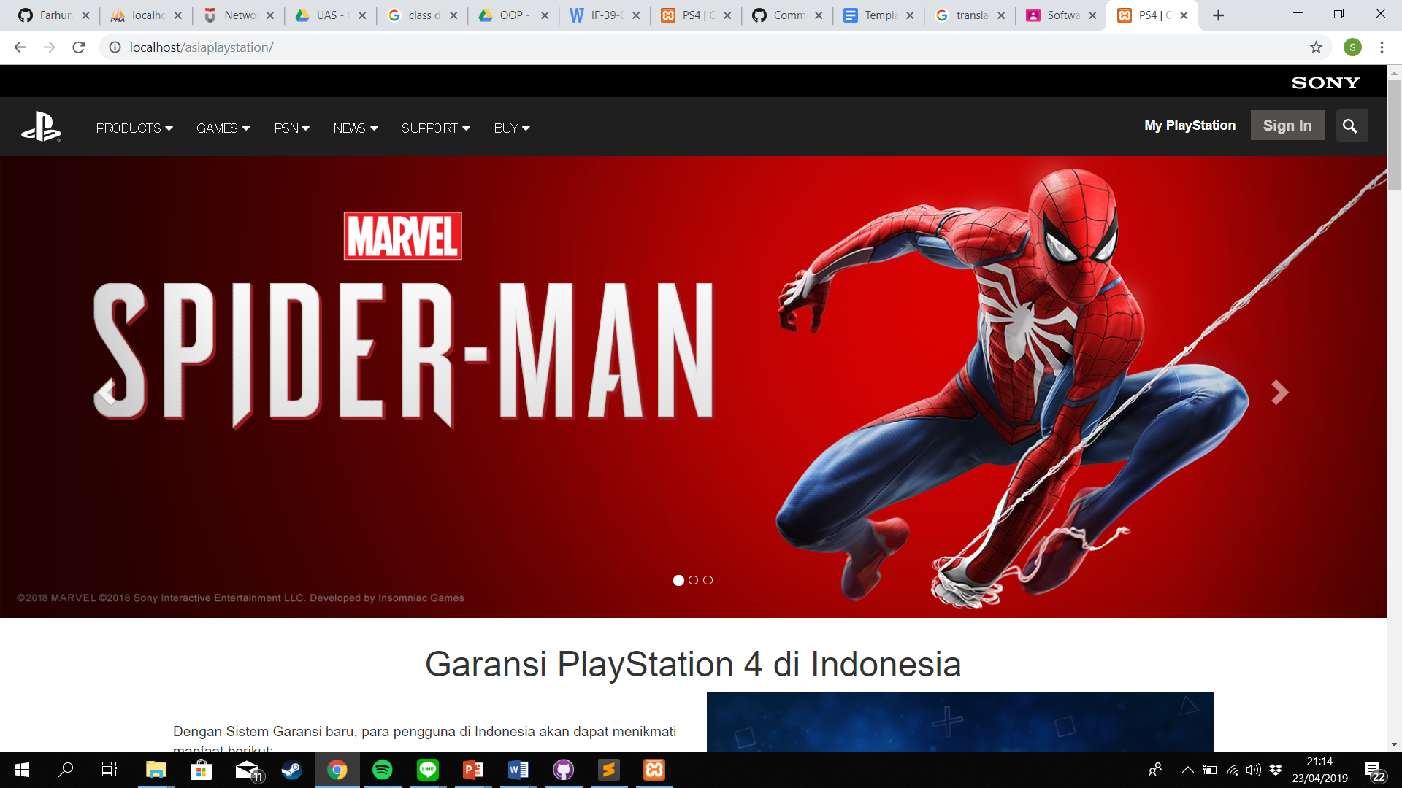

* Product page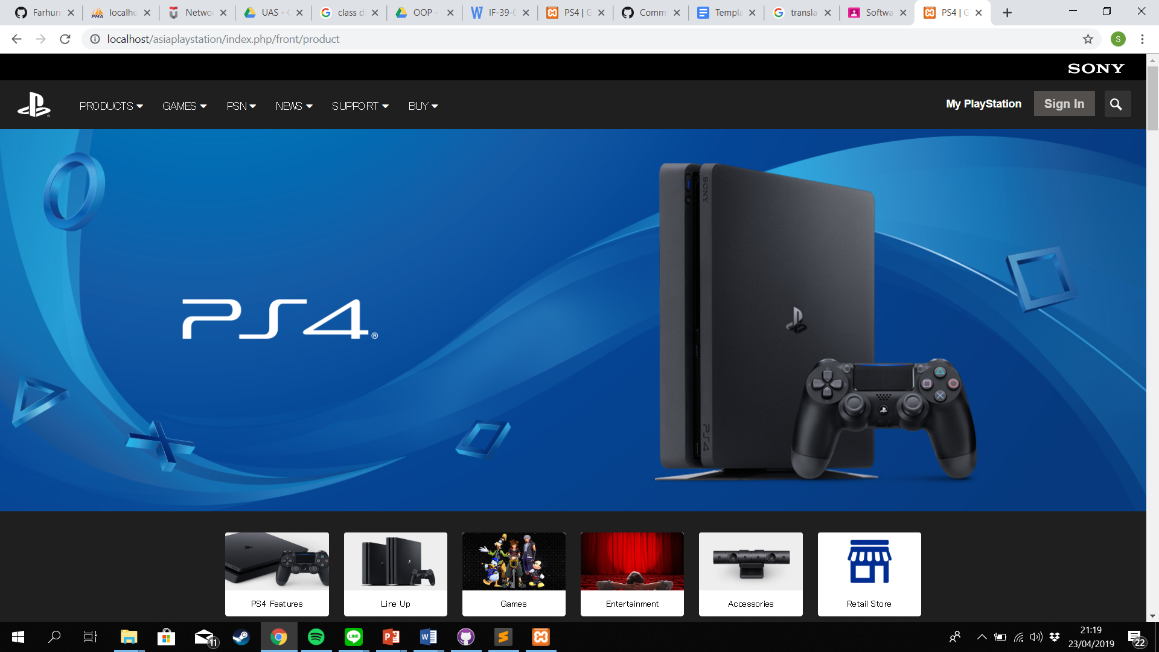
* Games page

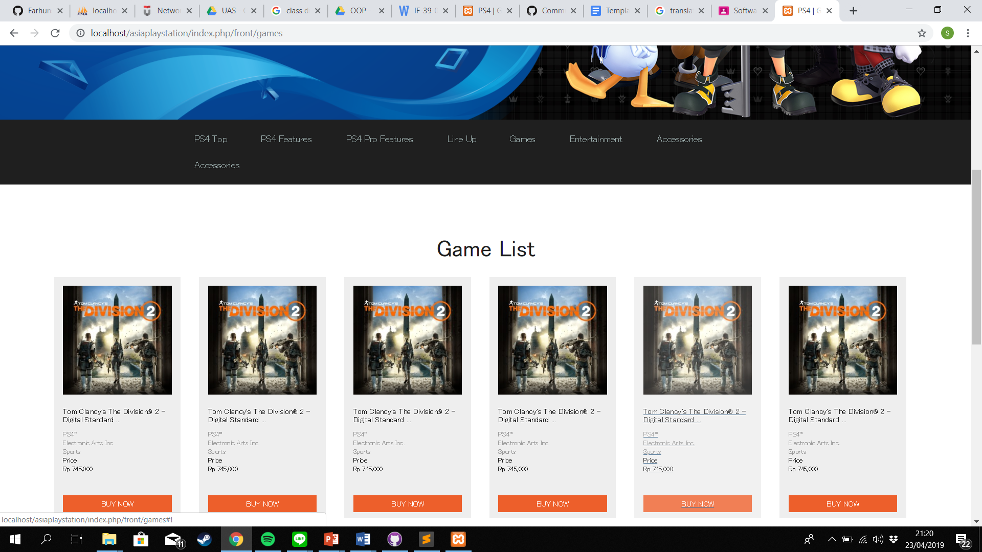

* Support page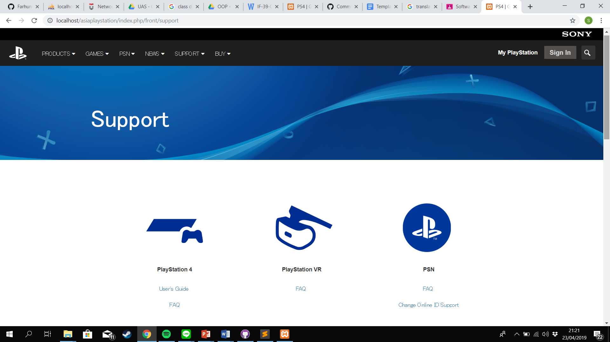
* Sign-in page

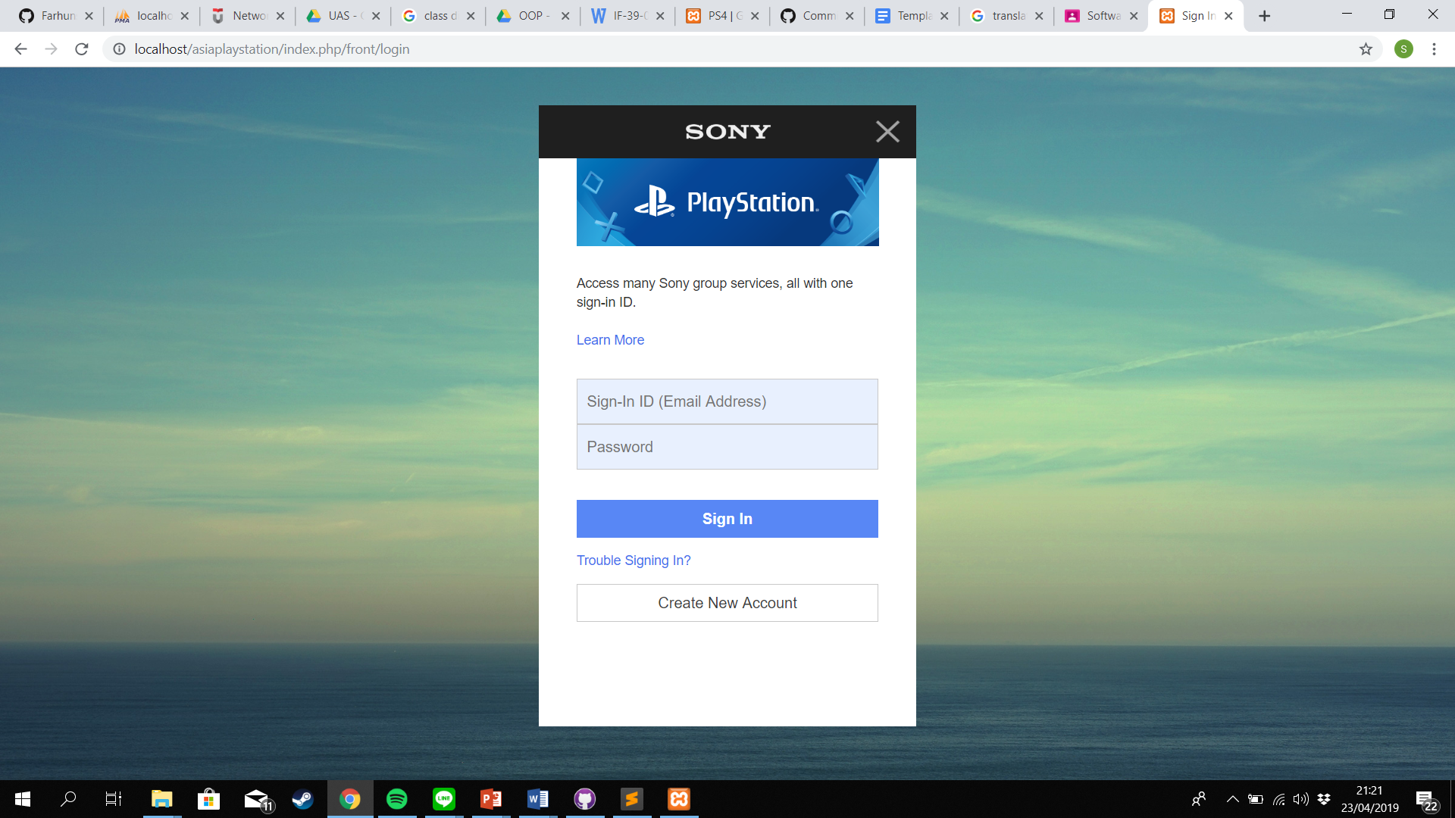

* Create account page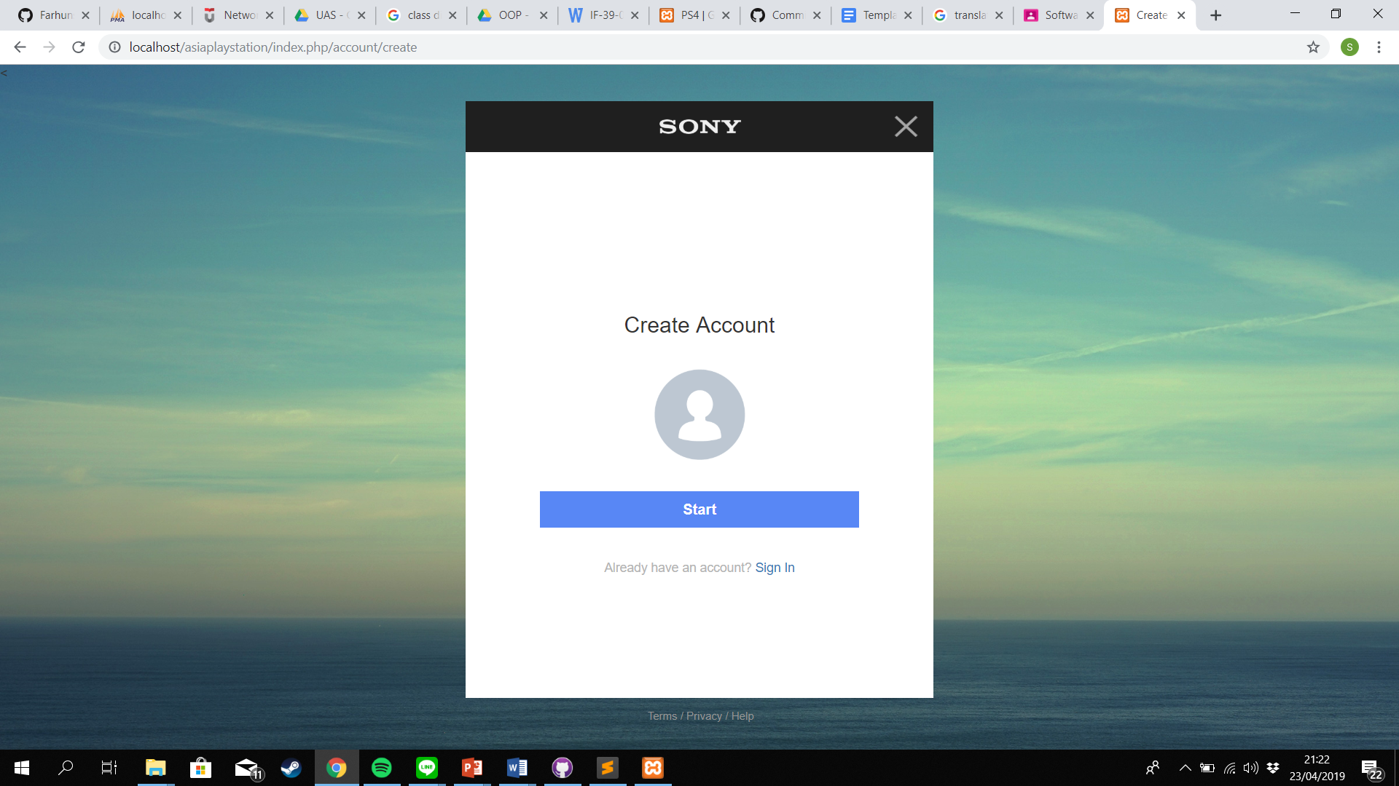
* Create account page (2)

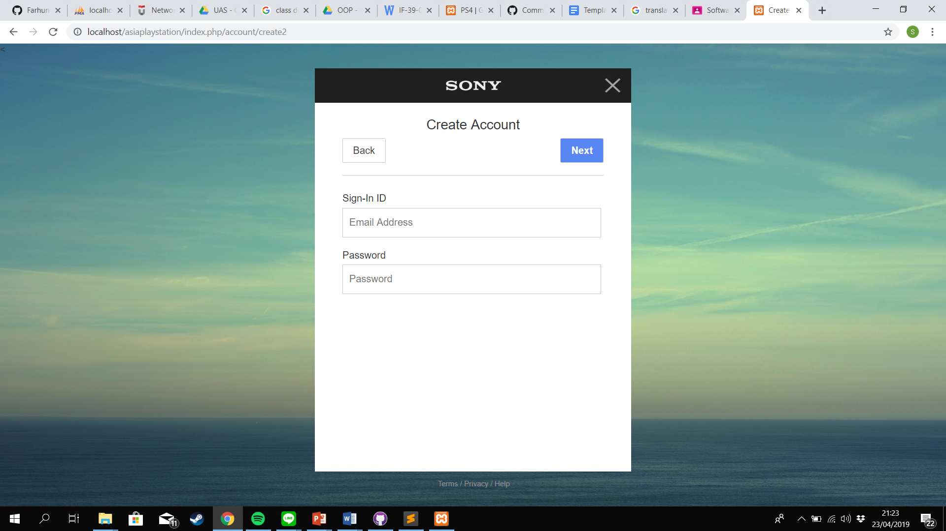

* Create account page (3)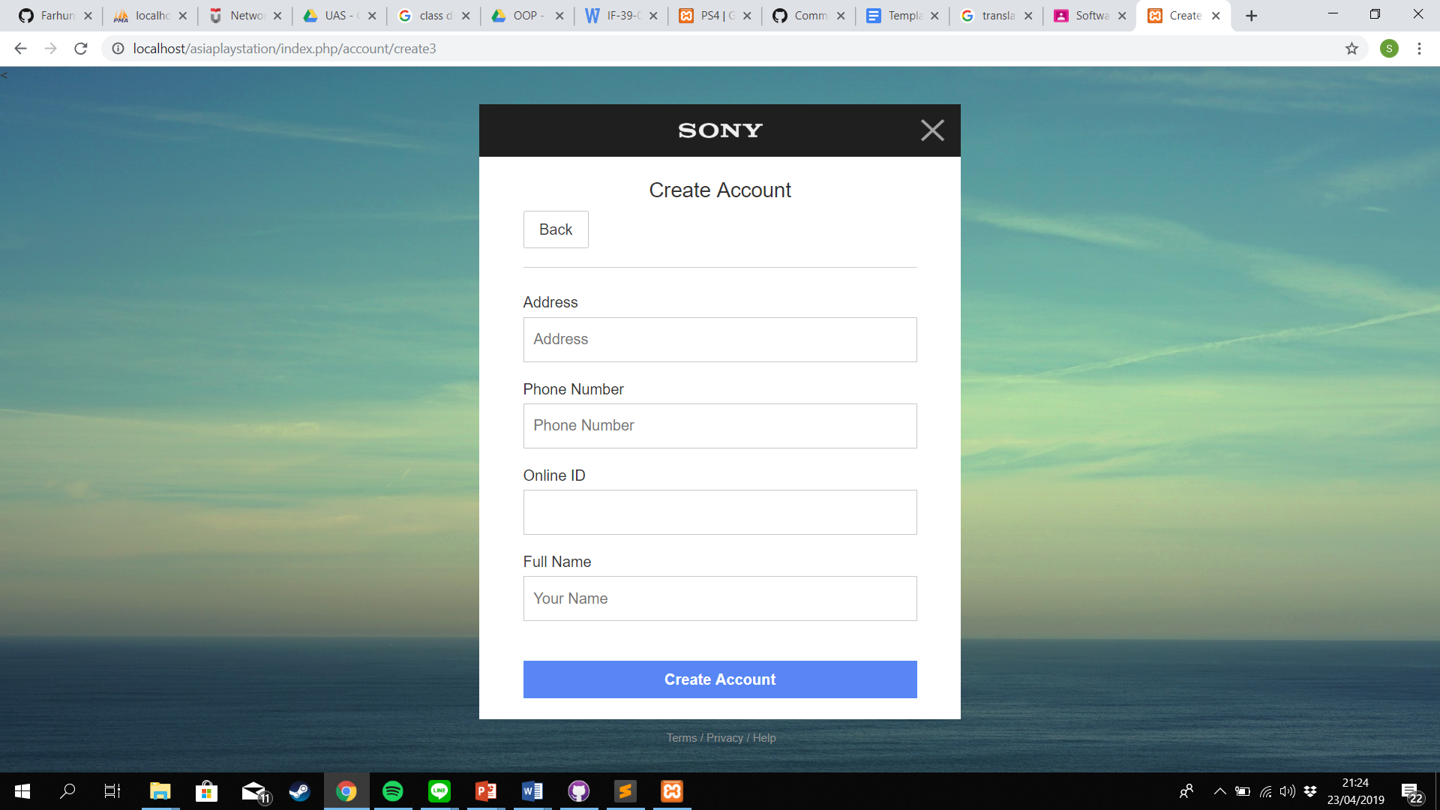
* Homepage after login as customer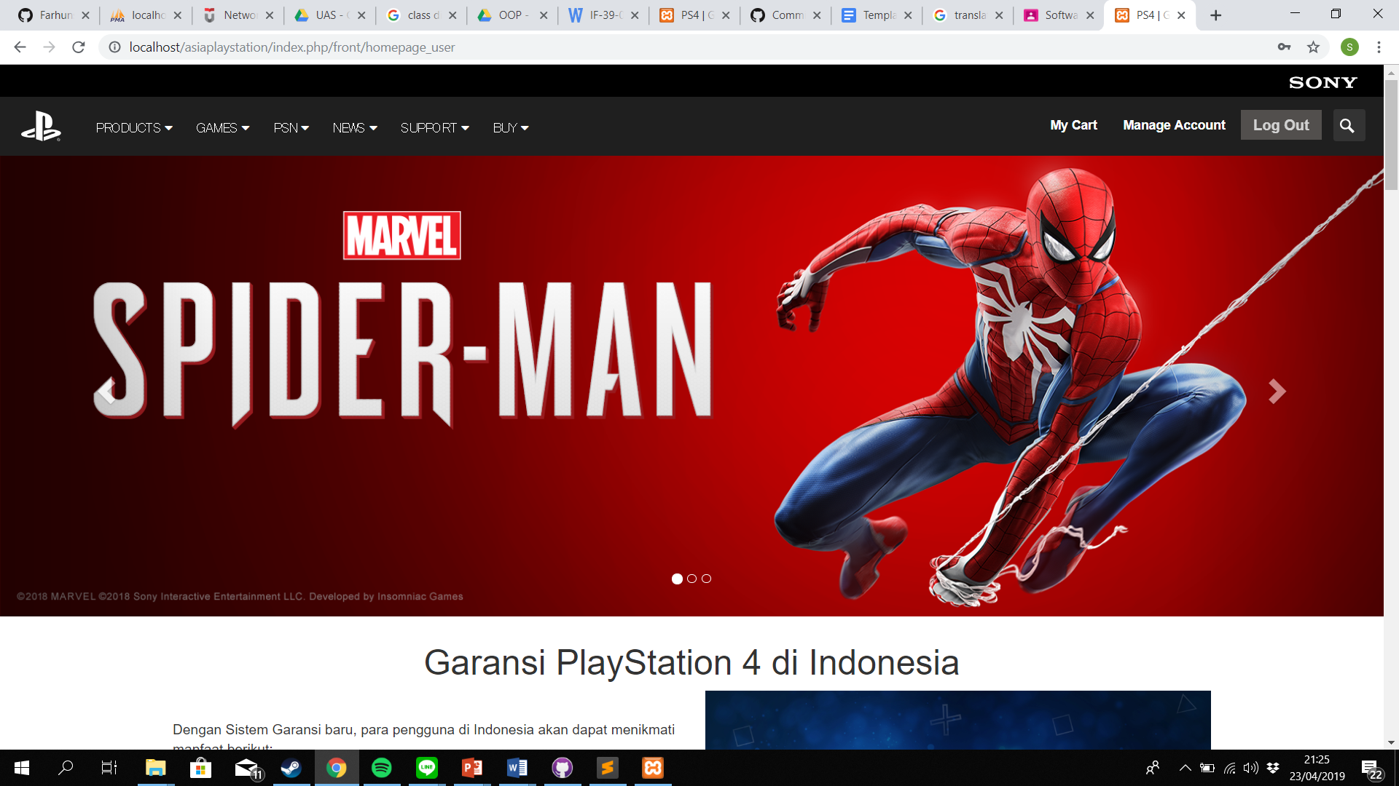
* Manage account

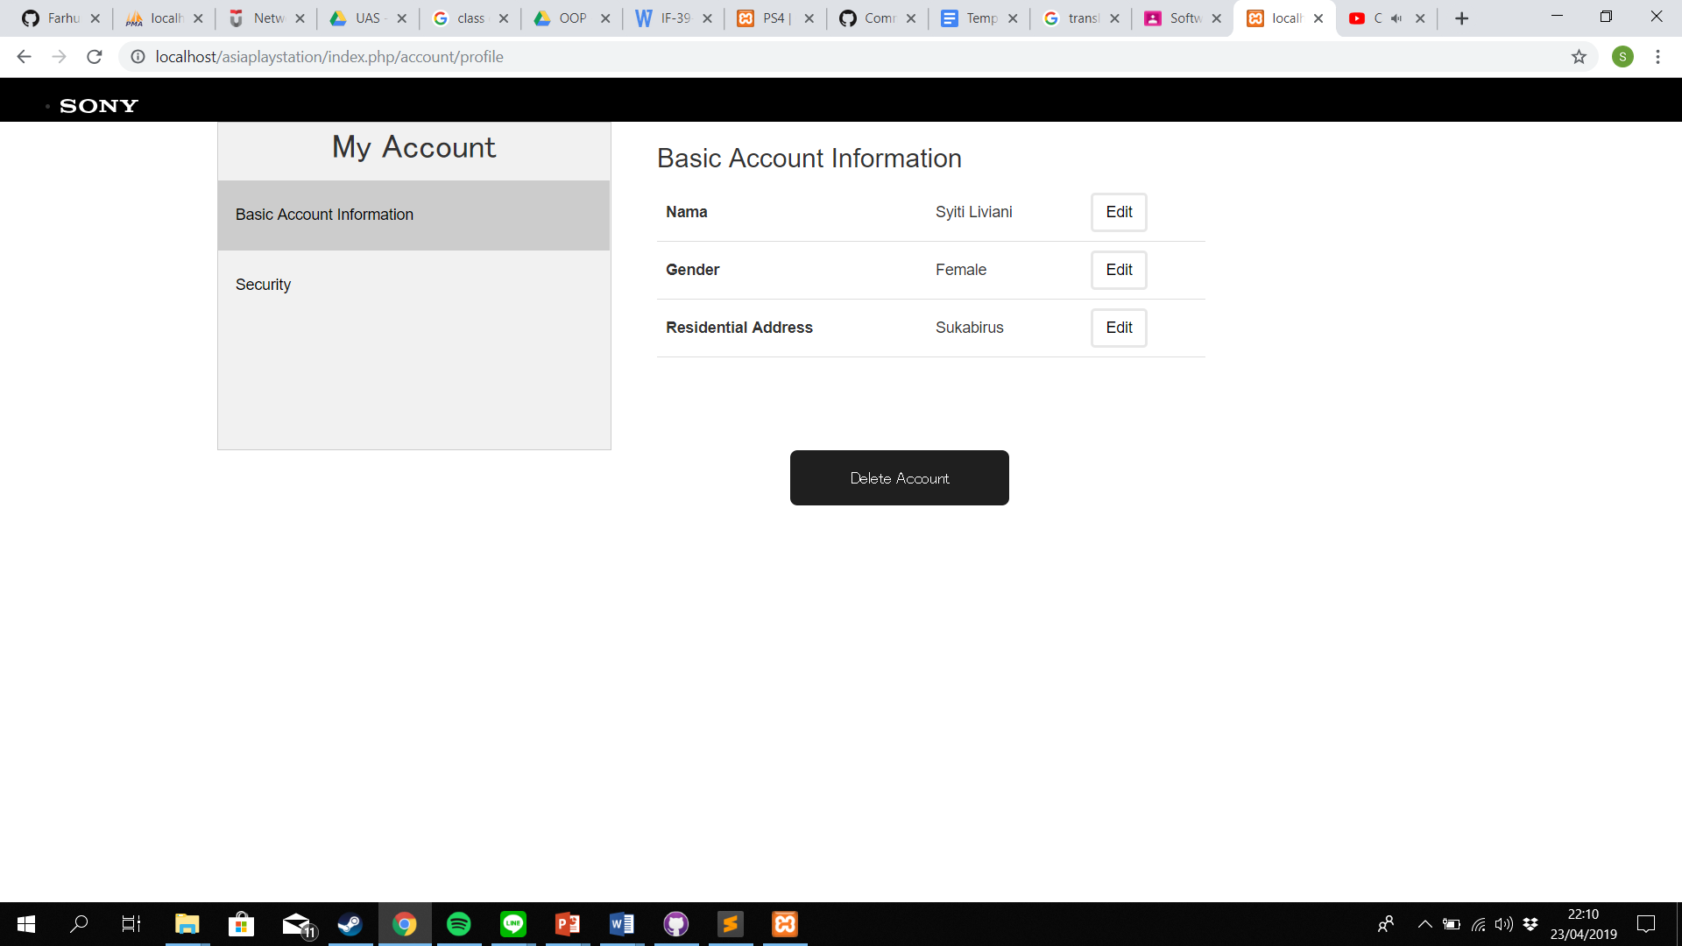

* Homepage after login as admin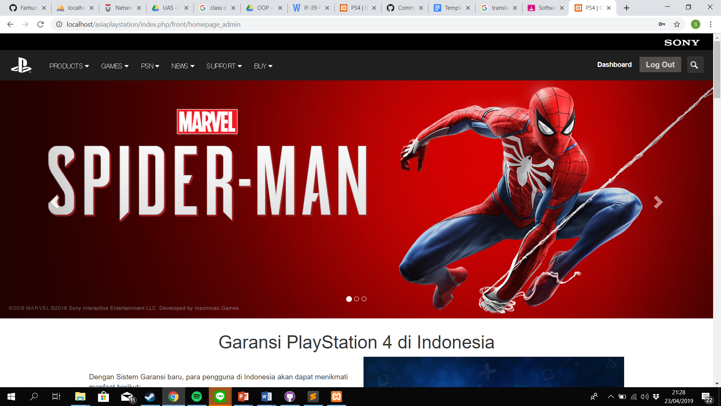
* Dashboard admin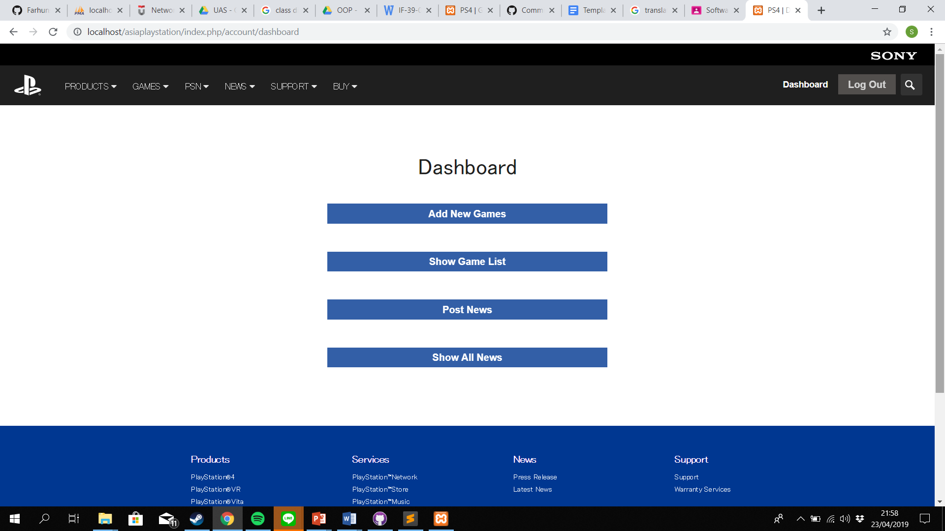
* Form to add new games

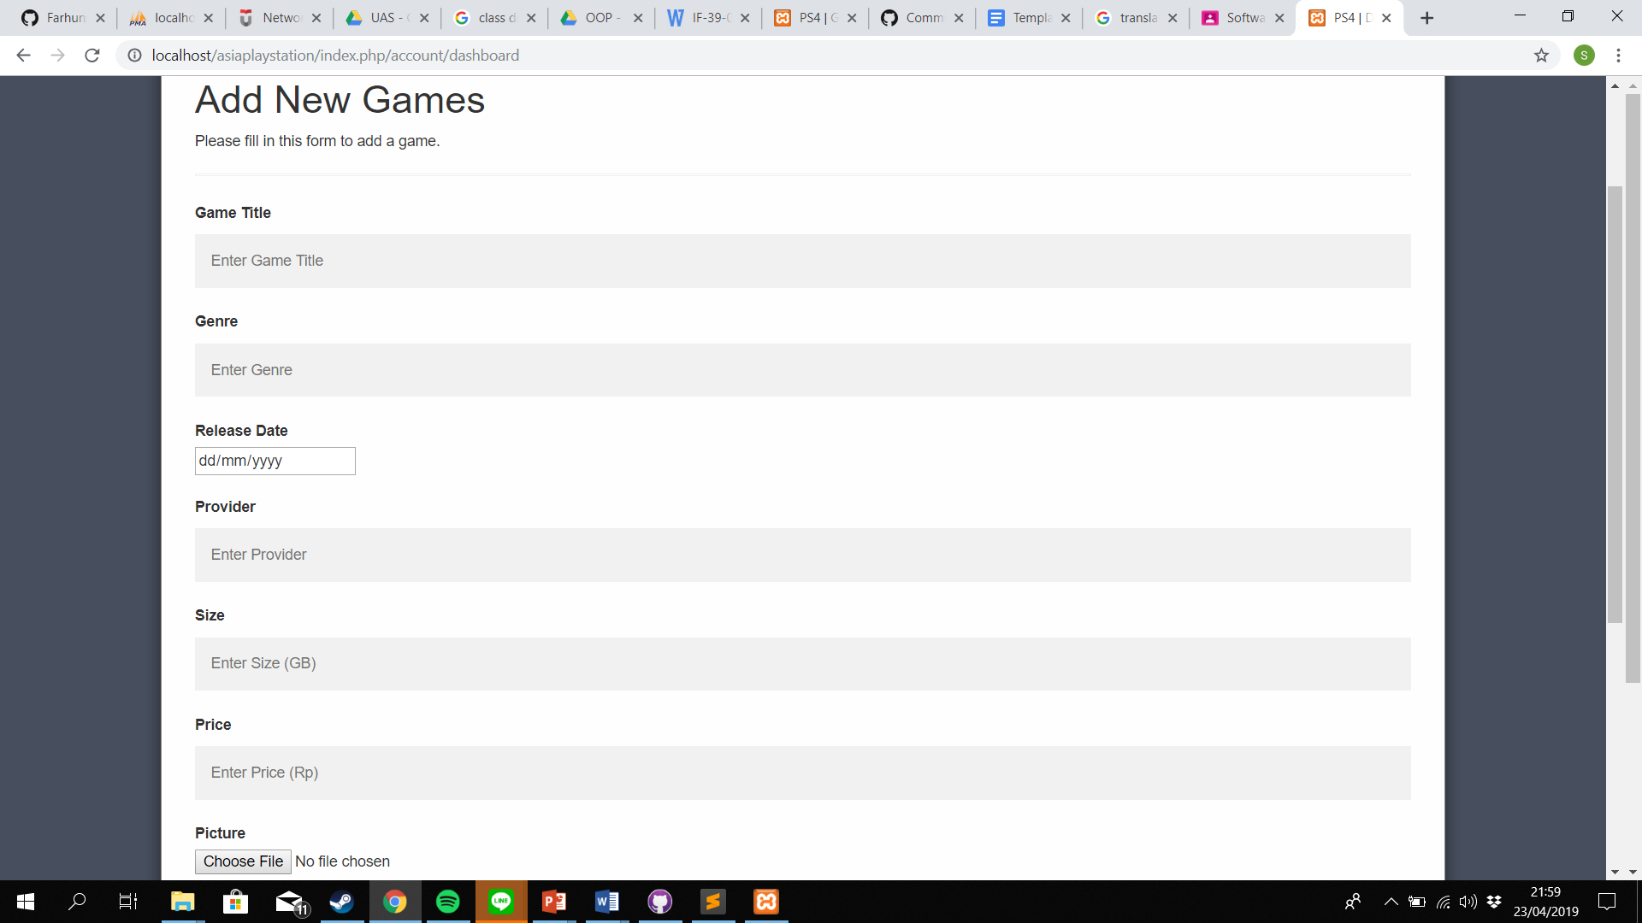

* Show game list